

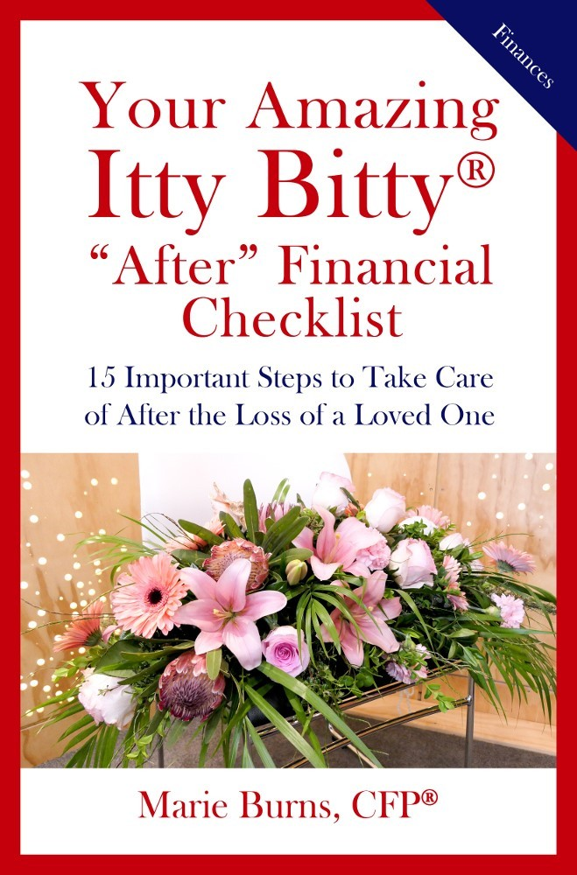

Simple, easy to follow steps that take the overwhelm out of finances before and after major life events.

Media **Kit**

Author Bio Book Bio

Target Audience Book Excerpt Interview Questions

Story Ideas for Reporters

Reviews Photos

Contact Author

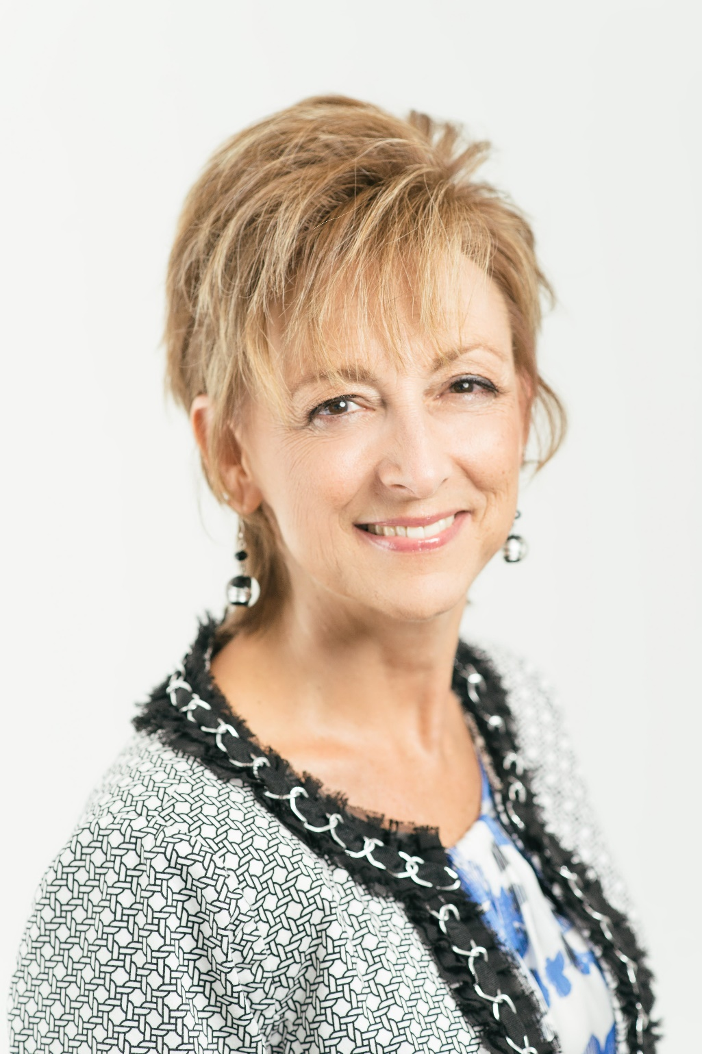

Author Bio

Marie

Burns,

a Certified

Financial

Planner™

(CFP®)

with insurance and securities licenses, has been advocating

for

clients

as a financial

advisor for close to 20 years.

She

is a

member

of

the

Financial Planning Association

nationally

and

locally,

100+

Women Who Care, Ahwatukee

Foothills Neighbors, Church.

Wisconsin, clients with

Friends and Mountain Originally

and Park from

she has

helped

their financial lives

in a bank setting, accounting firm, at Vanguard, at a financial planning firm and now enjoys

her

own

practice

with

an

independent

Registered

Investment Advisory firm. She

enjoys walking, especially

cooking,

reading,

hiking,

Zumba

and

creating

memories

with family and friends.



Book Bio

These Itty Bitty Books provide 15 steps that will help you update your financial records before you're gone, walk you through important actions on financial steps after the loss of a

loved one, and prepare you

and

your

family for what’s to come.

The “Before” checklist breaks down the updating of your financial records so it doesn’t feel so overwhelming

and you are more likely to take action

on

implementing

the necessary you save time, preserve family

steps. It will help stress, money and

relationships in the end.

The “After” checklist will help you get your financial house back in order.

Having a process, documented notes,

and an ordered action list can help you move forward with getting things updated while you and your family are recovering after the loss of a loved one.

The financial checklists are intended to get you thinking and talking to the right people and taking actions before and after the loss of a loved one. If you are trying to prepare for what’s to come or you are facing the loss of a loved one, these books will help ease the transition.





Target Audience

WHO SHOULD READ

•

Anyone starting to help aging parents

Anyone who has lost a spouse, parent, friend or other family member

Individuals or couples who are retired and beginning to think about the next phase of life

Families aware of a terminal condition and trying to prepare for what's to come

People of any age trying to get their financial house in order

•

•

•

•

BOOK BENEFITS

Save time, stress and money

Avoid additional costs/delays of probate

Learn who to notify, what professionals to speak with and what to talk to them about

Get financially organized

Understand and plan for final wishes

Preserve family relationships

•

•

•

•

•

•





Book **Excerpt**

**"Before" Step 10 Homework: Who Gets What?**

Remember that each beneficiary designation dictates the distribution of

each account so make sure all of your beneficiary designations are current. Too often we list someone - then, life changes, people pass away, or relationships change, so your beneficiary designations may need to change too.

**Beneficiary Designations**

•

The best person to give you advice on naming beneficiaries is your legal advisor. He/she understands the big picture of your estate and knows what it is you are trying to accomplish.

Discuss with your attorney the option to add "per stirpes" or "by rights of representation" wording (the ability to include grandchildren if their parents predecease you) to a beneficiary designation.

•

Too often, people misunderstand and believe that once their will or trust is drafted, that takes care of everything and that beneficiary designations don't matter because they have it all spelled out in their will or trust. But remember, a beneficiary designation acts like a little mini-will in dictating where each account gets distributed, so the account never references the will or trust for distribution instructions at all on most accounts unless the will or trust is listed as the beneficiary (and that may not be the best practice for tax reasons) or goes through probate because there was no beneficiary listed.

You need to consult your legal advisor for beneficiary designation recommendations - don't guess!



Interview Questions

Why is National Estate Planning Awareness Week important and what should we know about it?

1

6

Who will benefit most from this information?

What is the first step someone needs to take for the "before" and the "after"?

Why is it important to get our financial records organized and up to date?

2

7

How can people take the

overwhelm out of planning for certain life events?

3

What are a few helpful tips for getting financially organized?

8

How do people know if they are on the right track for this type of financial planning?

What are the most common mistakes people make related to this subject area?

9

4

Where can people go for more information or if they have more questions?

What is a good way to bring up this subject with our aging parents?

10

5



STORY IDEAS FOR REPORTERS:

1. **National Estate Planning Awareness Month/Week:** What is NEPAM/W and why should we aware?
2. **Estate planning:** What are the things to do and think about before seeing an estate planning attorney?
3. **The morbid details:** Deciding what will happen to your "things" when you die sounds gloomy. Why is it important?
4. **What so many late celebrities got wrong:** Celebrities are still in the news years after their death, but it's not about the legacy they thought they would leave behind. How does the average family plan properly so their estate is not a mess when they are gone?
5. **Expect the unexpected:** Is your family ready for you to unexpectedly be in the hospital or suddenly pass away?
6. **Where there's a will there's a way**: 60 percent of Americans die without a will. Why are beneficiaries so important?
7. **It's a family affair**: You’ve heard that money changes people, it’s true.





Reviews

"Marie has provided two amazingly simple, but well- defined booklets that answer the BIG questions for many who are anticipating, or have lost a loved one. I found them insightful because they took what felt like giant fears of “unknown tasks,” out of my journey as a new widow." Doreen Hanna, Founder of It’s A New Day Widow’s Ministry

“Marie is very knowledgeable, organized and professional! She shared much needed insight and information on topics we will all eventually face. Very helpful!”

New Adventures in Learning, Sun Lakes, AZ

“Marie’s approach is that of a trusted family friend – she compassionately walks you through every step that needs to happen and when. This book completely overcomes the feeling of overwhelm.” Arlene Pedersen

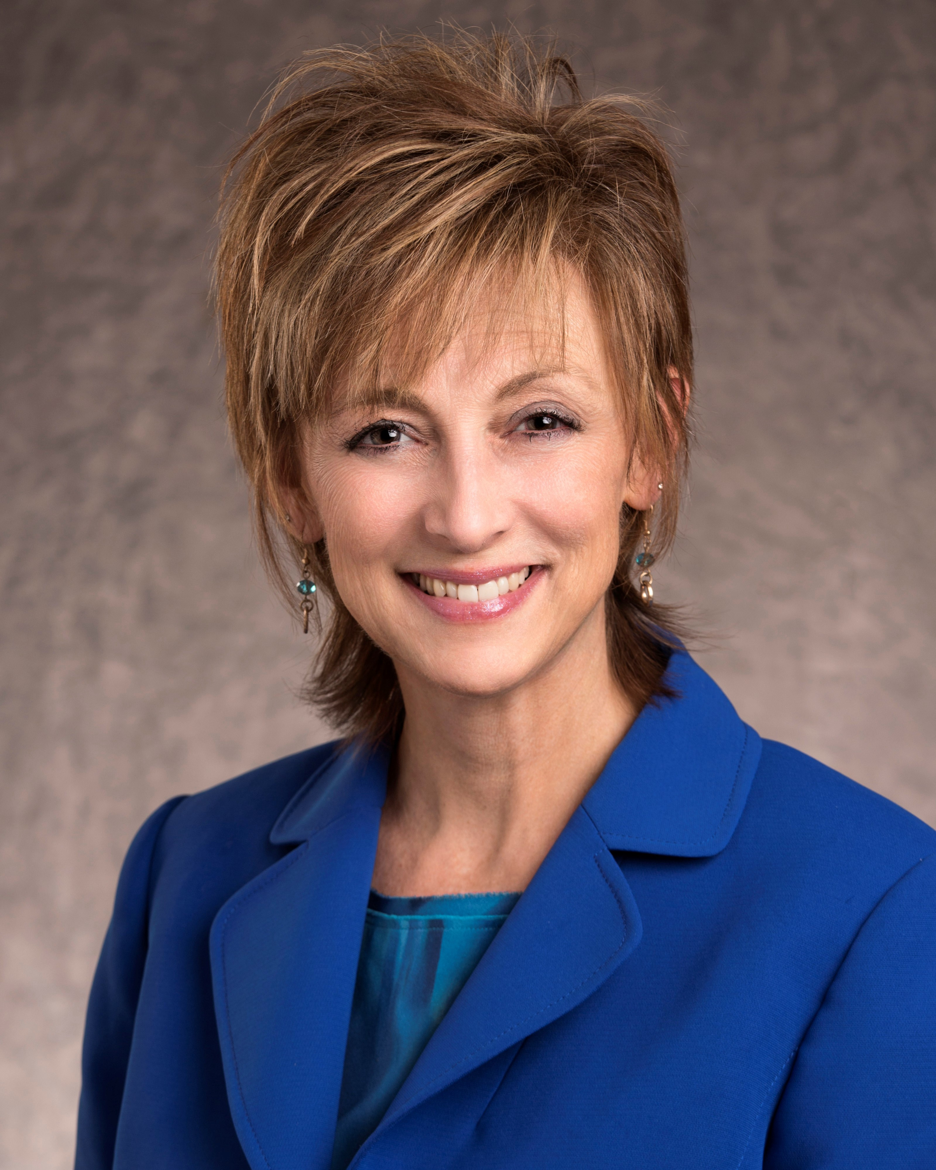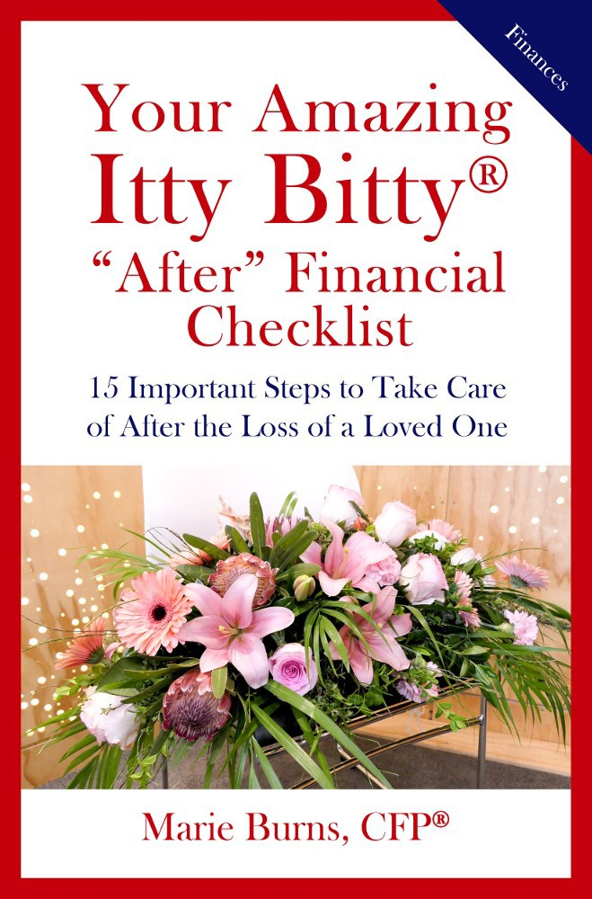

[Download High Res JPEG](http://www.paperlifesavers.com/wp-content/uploads/2018/10/Marie-Headshot-2.jpg)

[Download High Res JPEG](http://www.paperlifesavers.com/wp-content/uploads/2018/10/After-Book-Cover-hi-res.jpg)

[Download High Res JPEG](http://www.paperlifesavers.com/wp-content/uploads/2018/10/Before-Book-Cover.jpg)

DOWNLOADABLE PHOTOS

I appreciate requests for photographs for press use. Email and let us know where you post your article so we can link to it.

-Thank you.

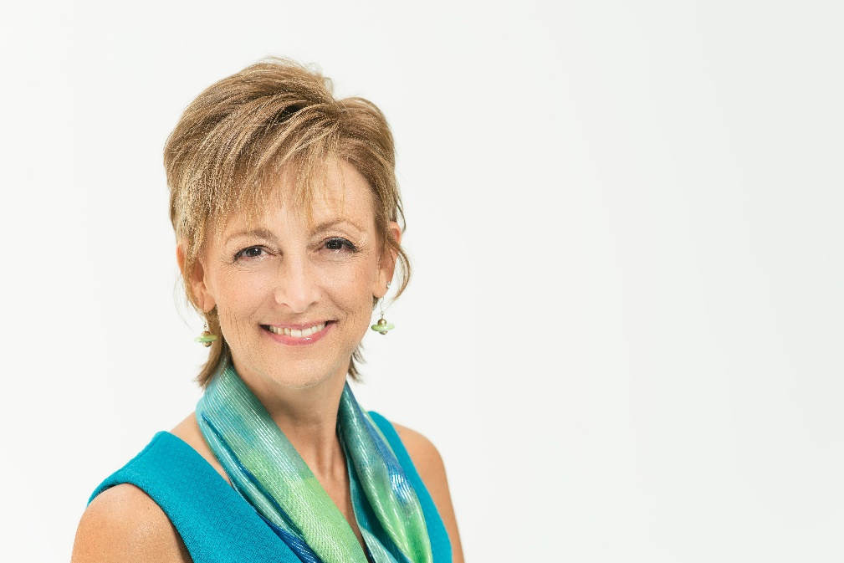

Connect with

**Marie Burns**

**Email:** [PaperLifesavers@gmail.com](mailto:PaperLifesavers@gmail.com)

**Phone:** 480.848.9447

**Website:** [**www.**Paperlifesavers.com](http://www.Paperlifesavers.com)

**Facebook:** facebook.com/paperlifesavers